Sprint 1 Progress Report – Task 5.2

Isaac Pittolo – 7695438  
Hoang Linh Bui – 100017631  
Adam Bubonya - 9986677

# Problems during Sprint Meetings

Our group had issues with communication for the duration of this sprint, as well as considerable outside factors causing us to be unable to even meet up, let alone work.

The top factor that caused us to have issues is both Adam and Isaac really do not understand the processes behind these Sprint meetings. It may even be an ego trip – admitting that you are having troubles contributing to a project is a difficult thing for us to do. Hoang is considerably skilled at program development and managing the project but due to a lack of communication between us all we really weren’t able to contribute anything directly.

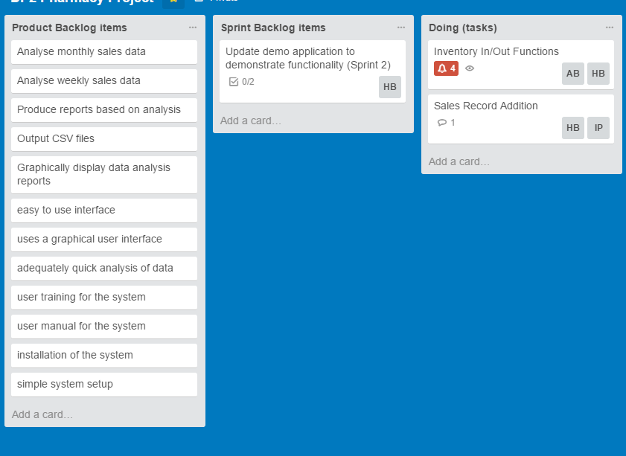

Figure 1 – Trello Chart as of start of Sprint 2

Figure 1 shows how our Trello chart looked at the beginning of Sprint 2. In reality, no progress at all has been made.

We have discussed methods to rectify this. We have guaranteed a time to meet up every night without exception – 9:30pm on Skype. Adam is to record the meeting minutes and screen capture the Burndown and Trello charts.

Finally, we have to learn to communicate better, talk about any problems we may have in the future as well as learn to ask for help if we need assistance.